SHOPNEST STORE POWER BI CAPSTONE REPORT
- Introduction
This report presents a comprehensive business analytics dashboard developed using Power BI for the ShopNest retail dataset. The dashboard provides insights into sales performance, delivery efficiency, customer payment preferences, product ratings, seasonal trends, and revenue growth. Various visualizations, KPI cards, and drillthrough functionality were used to answer key business questions and support data-driven decision-making.
Dashboard KPIs:
• Total Revenue: 13.59M
• Total Orders: 99K
• Delayed Orders: 8K
• Average Rating: 4.07

QUESTION 1: TOP 10 PRODUCT CATEGORIES BY TOTAL SALES
Question Statement:
Identify and visually represent the top 10 product categories by total sales.
Visualization:
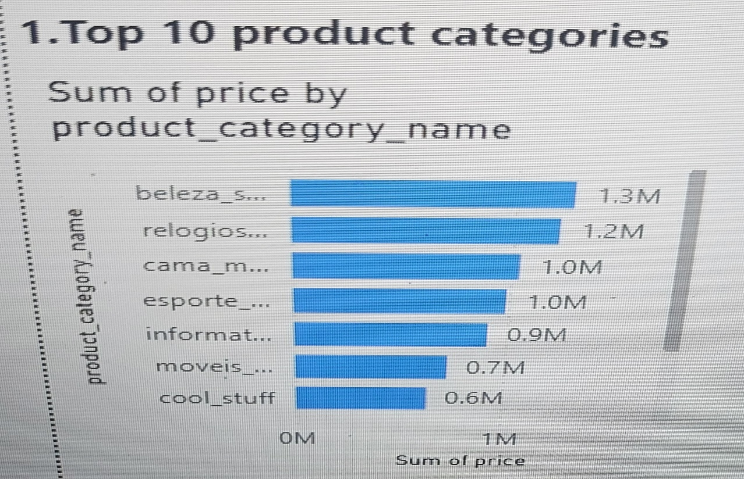
Explanation:
The bar chart displays the ten product categories generating the highest sales revenue. Beauty products, watches, bed and bath products, sports and leisure items, and computer accessories are among the leading categories. This analysis helps identify high-performing product segments and supports inventory and marketing decisions.

QUESTION 2: DELAYED ORDERS ANALYSIS
Question Statement:
Determine the number of delayed orders in each product category.
Visualization:
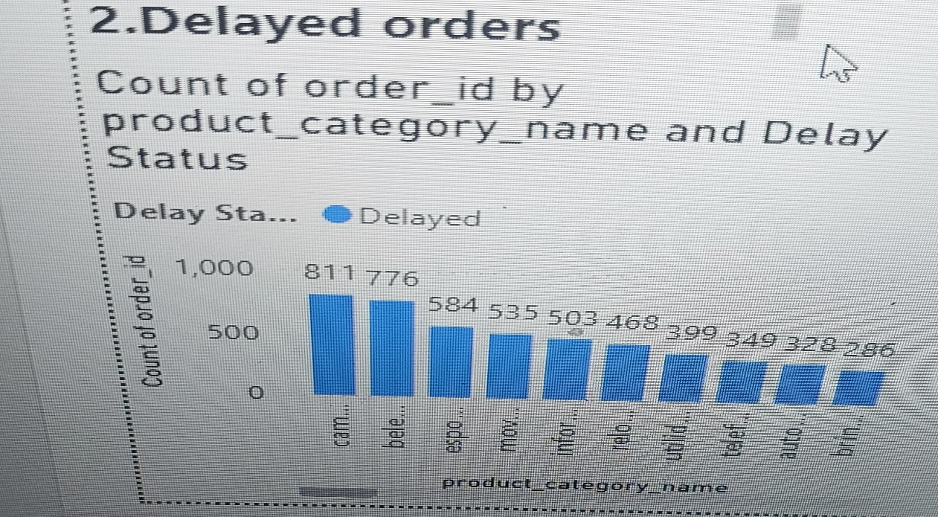
Explanation:
An order is considered delayed when the actual delivery date exceeds the estimated delivery date. The chart highlights product categories with the highest number of delayed deliveries. Understanding delay patterns helps improve logistics performance and customer satisfaction.

QUESTION 3: MONTHLY COMPARISON OF DELAYED VS ON-TIME ORDERS
Question Statement:
Compare delayed and on-time orders on a monthly basis.
Visualization:
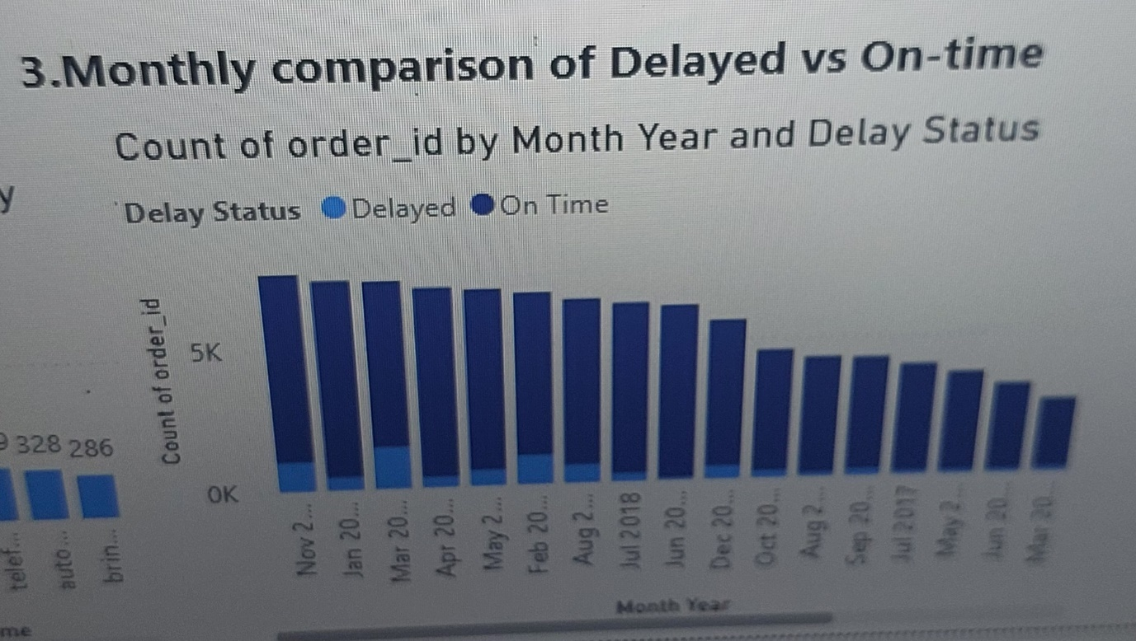
Explanation:
The stacked column chart compares delayed and on-time deliveries across different months. Most orders were delivered on time, while delayed orders accounted for a smaller proportion. This analysis provides insight into delivery performance trends and operational efficiency throughout the year.

QUESTION 4: PAYMENT METHOD ANALYSIS
Question Statement:
Analyze the most frequently used payment methods.
Visualization:
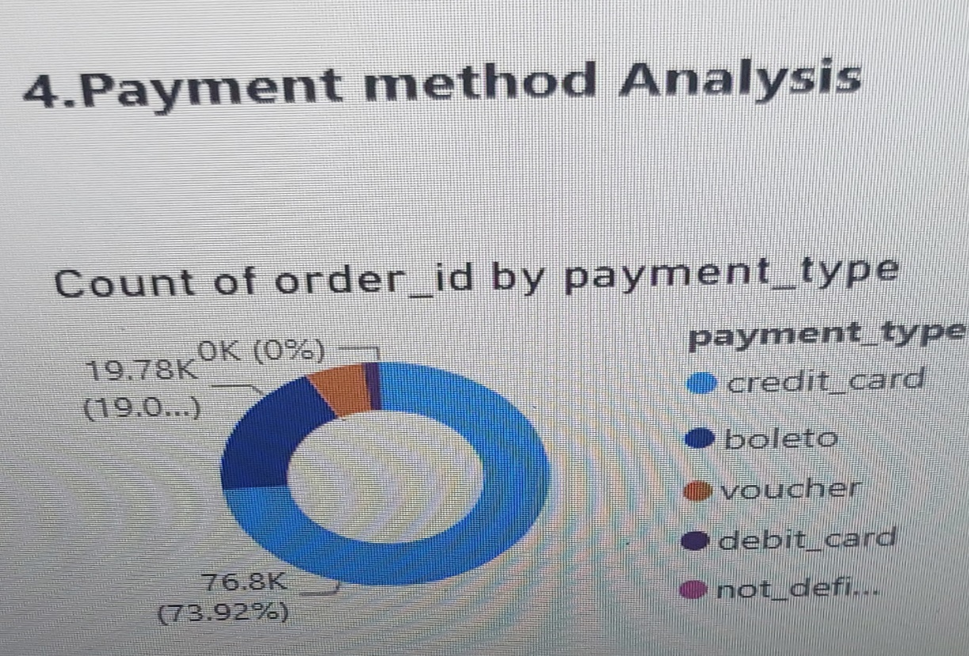
Explanation:
The donut chart shows customer payment preferences. Credit cards account for the majority of transactions, followed by boleto payments. Voucher, debit card, and other payment methods contribute a smaller share. This information helps understand customer purchasing behavior and preferred payment channels.

QUESTION 5: PRODUCT RATING ANALYSIS
Question Statement:
Determine the top 10 highest-rated and bottom 10 lowest-rated products.
Visualization:
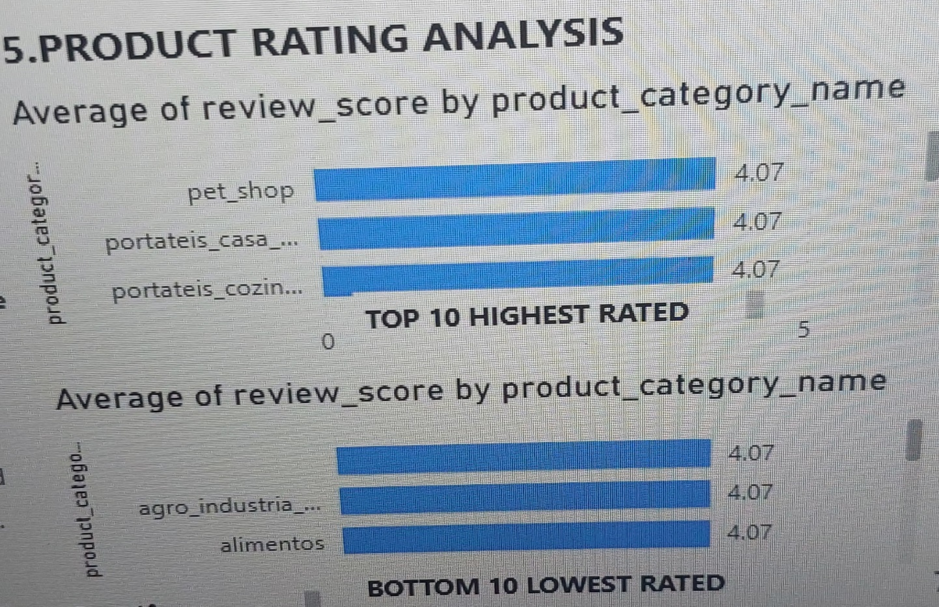
Explanation:
The charts display product categories based on average review scores. Highly rated categories demonstrate strong customer satisfaction, while lower-rated categories may require improvements in product quality, packaging, or service. This analysis supports quality enhancement initiatives.

QUESTION 6: STATE-WISE SALES ANALYSIS
Question Statement:
Identify states with high and low sales performance.
Visualization:
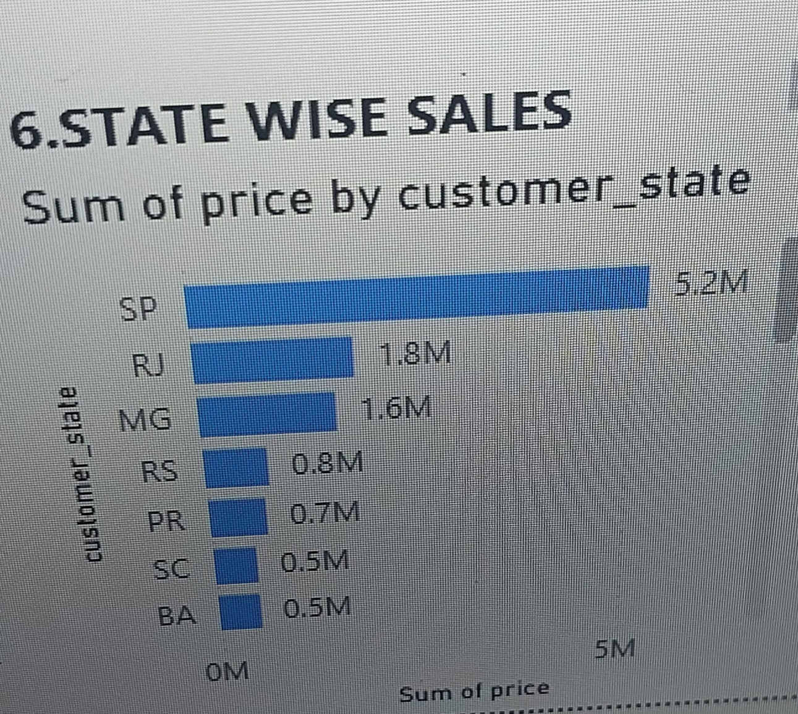
Explanation:
The state-wise sales chart reveals the geographical distribution of revenue. São Paulo (SP) generates the highest sales, followed by Rio de Janeiro (RJ) and Minas Gerais (MG). The analysis helps identify key markets and potential growth opportunities in different regions.

QUESTION 7: SEASONAL SALES PATTERN ANALYSIS
Question Statement:
Analyze quarterly sales trends.
Visualization:
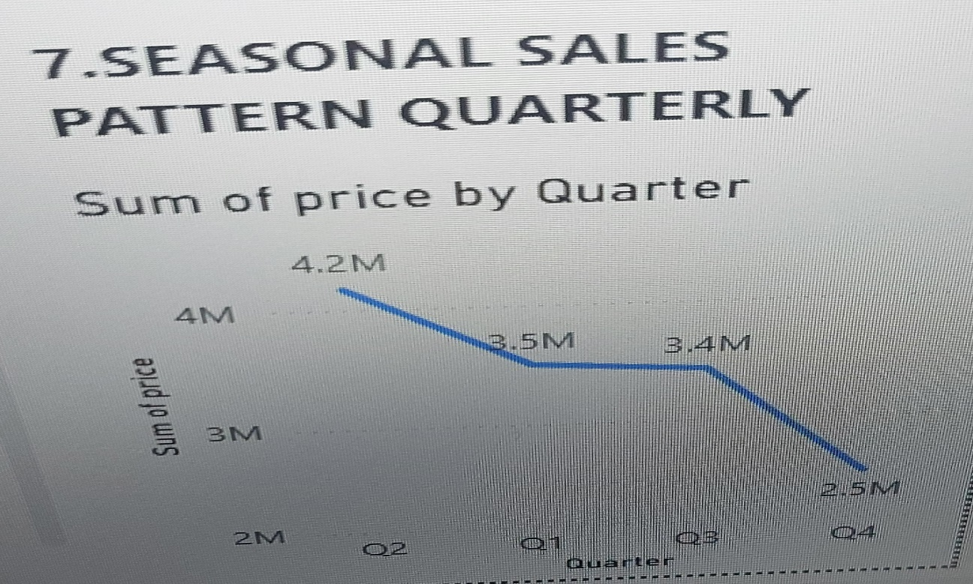
Explanation:
The seasonal sales chart shows revenue distribution across quarters. Sales are highest during Q2 and gradually decline toward Q4. This analysis helps identify seasonal demand patterns and supports planning for promotions, inventory management, and forecasting.

QUESTION 8: REVENUE ANALYSIS (YEARLY)
Question Statement:
Analyze yearly revenue trends.
Visualization:
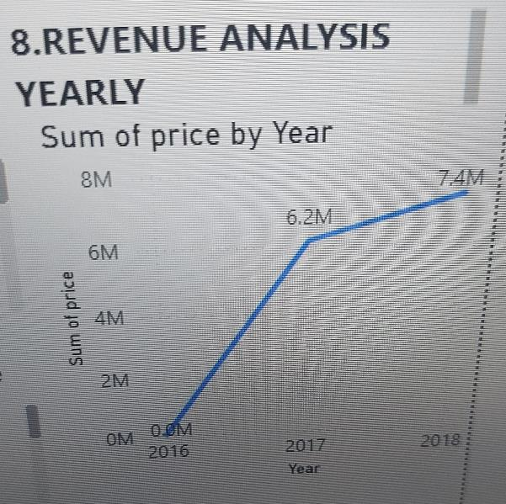
Explanation:
The yearly revenue chart demonstrates significant growth between 2016 and 2018. Revenue increased sharply from 2016 to 2017 and continued growing in 2018. The trend indicates positive business expansion and improved overall sales performance.

DRILLTHROUGH FUNCTIONALITY
A drillthrough page named "Delivery Details" was created to provide detailed order-level information. Users can right-click on a month in the Monthly Comparison chart and navigate to the Delivery Details page, which displays filtered order information including Order ID, Delay Status, Estimated Delivery Date, and Actual Delivery Date.

CONCLUSION
The ShopNest Power BI Dashboard successfully provides insights into sales performance, customer behavior, product quality, delivery efficiency, seasonal trends, and revenue growth. The dashboard enables business users to monitor key performance indicators, identify operational challenges, and make informed decisions based on data-driven insights.

